## **Image Mosaic**

# Mosaics background

A mosaic is an image made up of lots of small pieces. This technique dates back approximately 5000 years, to the ancient Babylonians who made elaborate mosaics with colored tiles. (photo stolen from Wikipedia)

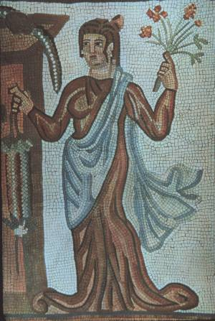

# Image mosaics

In this assignment you will need a large base image, and a collection of small tile images. I recommend you manually go to a wallpaper website and grab 10 – 20 images that can be smallish, like 640x480 resolution. I would also resize them to all be the same size, like 80x60.

For example we could have a base image that looks like this:

 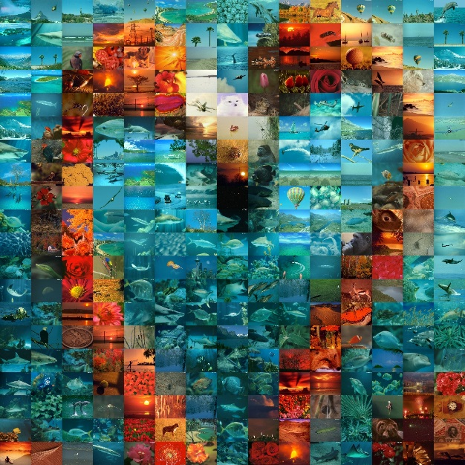

The original image of the flamingos was 1200x1200

It was then broken up into little areas that are each 80x60 pixels. Then you need to have a collection of images that are small, 80x60 in this case, where you match the color.

How do you match the color? Well, there are a few different ways. The crudest way is to find the average colour of the spot on the base image, and match that to the average color of a tile image. If you keep the average for each color in RGB, for each tile image, then you can quickly find the matching tile.

I have provided a starter file, so you can see some of the ways of loading and reading an image file in Java. I used the java.awt.image.BufferedImage library, which can read and write JPG, PNG and GIF image file formats. You can read more at the link below:

https://docs.oracle.com/javase/tutorial/2d/images/

In my implementation, I do not display the final image to the screen, as long as the final result is saved to an image file.

Once you have completed the basic operations, there are many ways that you can improve on the quality of the resulting image. The easiest is just improving the size of your tile library. You can do more detailed matching, or blend the original image colors into the tile images. You can also weight the different colors to get a better intensity match. Then there a few dozen more ways if you want to chat with me on it ☺

When you get this far, it’s time to get creative! Choose an interesting base image, and perhaps find an interesting collection of tile images.